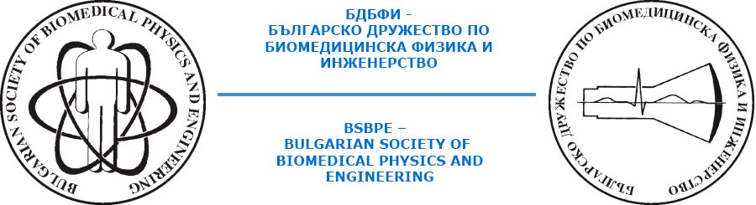

XIV-th NATIONAL CONFERENCE ON MEDICAL PHYSICS AND BIOMEDICAL ENGINEERING

with international participation

date: 8 November 2024

place: Sofia, Bulgaria

AGENDA

10.00h – Opening ceremony
10.15h – Presentations
Chair: Prof. J. Vassileva
M. Stoeva – International Organization for Medical Physics - Inspiration for future generations of medical physicists
M. Israel - The "unpopular" activities performed by medical physicists to protect the health of the population
J. Vassileva - Problems and solutions for providing radiation protection to patients
Y. Baneva - Radiation protection around the world
D. Kostova-Lefterova - Problems in communication and access to up-to-date information in X-ray diagnostics during pregnancy
11.30h – Coffee break
12.00h – Presentations
Chair: Prof. Christina Bliznakova
C. Bliznakova - Advances by the ELPIDA Research Group in Technologies for Breast Screening and Diagnosis
A. Zagorska - National project BUL9026 to the IAEA on the topic "Increasing the quality and ensuring the protection of patients during high-dose medical imaging studies" - achieved results
K. Romanova - Analysis of patient doses and exposure parameters used during different radiographic examinations with three DR systems
D. Ivanova - Piloting software to analyze and track patient doses across various CT scans
P. Simeonov - Pilot application of a platform for calculation of mean glandular dose in mammographic X-ray examinations
Y. Baneva - Chat GPT in radiology
13.30h – Break for lunch
14.00h – Presentations
Chair: Prof. Mihaela Ivanova
M. Ivanova - Application of national legislation for the protection of laser radiation workers
V. Zaryabova - Exposure assessment of electromagnetic field from telecommunications sources in populated areas in correlation with public concern
V. Zochinova - Pilot study of microclimate in educational institutions
P. Marinov - The influence of photon ionizing radiation generated by a medical linear accelerator (LINAC) on the physicochemical properties of gold nanoparticles
I. Dyakov - Comprehensive study of the utilization of different breast imaging modalities
15.00h – Poster session and presentations from the support companies
15.30h – Close ceremony

